

Migration of NoSQL data(Amazon DynamoDB) to Relational data warehouse(Amazon Redshift) using AWS Glue ETL Jobs.

**About Convosight**

**About Challenge**

Convosight is **the world's first community management platform** that uses the power of data analytics and machine learning to help admins and brands create, moderate, grow and leverage communities meaningfully.

Convosight is the world's first community management platform. 45000 Facebook group admins trust Convosight to manage over 300M+ members, it helps them increase engagement, reduce SPAM and become community entrepreneurs.

Convosight is growing in business so it needs a robust, more secure and easily accessible and developer friendly system. So, Convosight is in place to bring all its existing external 3rd Party Services like Elastic Cloud to be migrated to cloud platforms like AWS(Amazon Web Services).

The major challenges we faced:

* The indices has to follow a specified regex. It must include a number and ‘-‘
* The shard size of Elastic cloud is around 800GB however according to best practices the max shard size of Amazon ES is 50GB
* To enable migration it is necessary that the status of cluster has to be green i.e at least there should two replication nodes

**AWS Services used**



**Proposed Solution**

MIND team analyzed the problem and proposed the following solution:-

* Create S3 bucket to store snapshot of elastic cloud snapshot.
* Take manual snapshot of Elastic Cloud using Kibana-> dev tools.
* Restore the manual snapshot in ES Cluster.
* ISM template was set in the policy which will include the specified regex pattern
* To accommodate Elastic Cloud of 800 GB, the EBS volume was increased to 1TB

**Solution Outcome**

* Migrated entire workload from elastic cloud to Amazon Cloud
* Inplace upgradation was done for previous workload.
* Provided with inbuilt visualisation and reporting tool for monitoring and alerting
* Increased data ingestion capabilities.
* d

**Architecture Diagram**

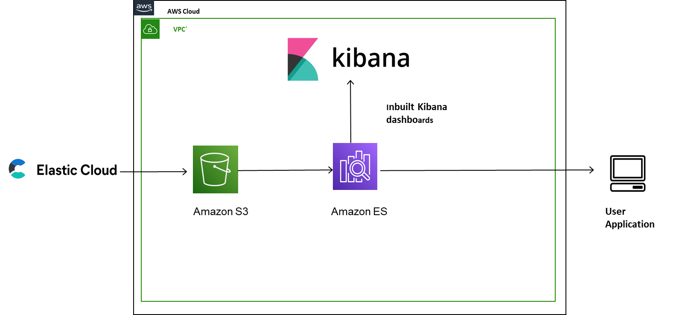

**How AWS services helped in the Migration**

**Amazon OpenSearch for analytics and visualization**

It is fully open-source search and analytics engine for log analytics, real-time application monitoring, click stream analytics and search backends. It will provide ultra warm and cold storage for read-only data. It is being used for application search and log analytics with dashboards and visualisation tools for reporting.

**Amazon EC2 for creating clusters**

Amazon Elastic Cloud Compute (EC2) provides scalable computing capacity in the Amazon Web Services(AWS) Cloud To use OpenSearch service, you first need to create OpenSearch cluster. OpenSearch internally uses EC2 as clusters. Each EC2 cluster instance in a cluster acts as one OpenSearch service node.

**Amazon EBS to scale storage for EC2**  
Amazon Elastic Block Storage(EBS) allows you to create storage volumes and attach them to EC2 instances. EBS is used with EC2 to store persistent data.

**Amazon S3 to store**

Amazon Simple Storage Service(S3) is an object storage service that offers industry-leading scalability

data availability, security and performance. Amazon S3 is used to store the manual snapshot taken from Elastic Cloud storage.

**About the Partner**

**MothersonSumi INfotech &Designs Ltd.**

MothersonSumi INfotech & Designs Limited (MIND), a SEI CMMI Level 5 IT services company and the IT back bone of Motherson group. MIND is a trusted technology partner to over 200 clients globally. Our value proposition is in our strength in specific Industry segments and years of experience in the areas of intelligent warehousing, Supply chain enablement, software application development, smart ERP customization, infra managed services, cloud, IoT & Analytics. MIND is serving customers in 41+ countries with a strong team of 1500+ professionals.